**How to Use Canva to Create a Poster**

1. **Sign up for a free Canva educator account.**

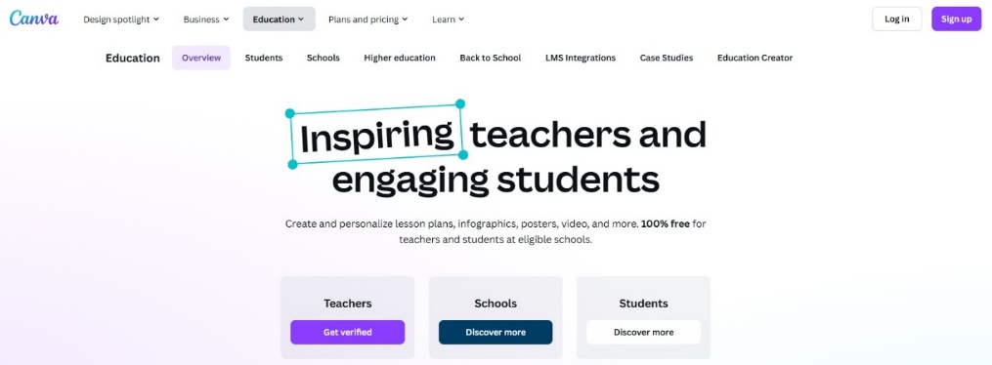

Source: <https://www.canva.com/education/>

You can get verified as an educator and invite your students to join your group. Students can also sign up individually by using their school SSO email address.

Once students are signed in, you can choose how they’ll work, individually, in pairs, or collaborating on a group project.

1. **Collaborating**

Source: [canva.com](https://www.canva.com/)

If students choose to collaborate, the teacher can create a poster, click on the ‘Share’ button in the top right corner, then add email addresses for each member of the group. A simpler solution would be for a student to create a poster, click ‘Share’, click on the arrow next to ‘Only you can access’, and change the sharing permission to ‘Anyone with the link’. They can then copy the link and share the link with anyone whom they wish to collaborate. Anyone who clicks on the link will have full collaboration access.

1. **Search for a poster template.**

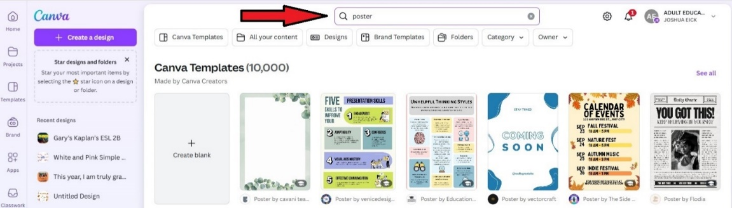

Source: [canva.com](https://www.canva.com/)

Students can choose to begin with a blank canvas or choose from a template. However, if they choose a template, they’ll have to alter everything that they don’t want or want to change. It may be easier to begin with a blank canvas.

1. **Create text**

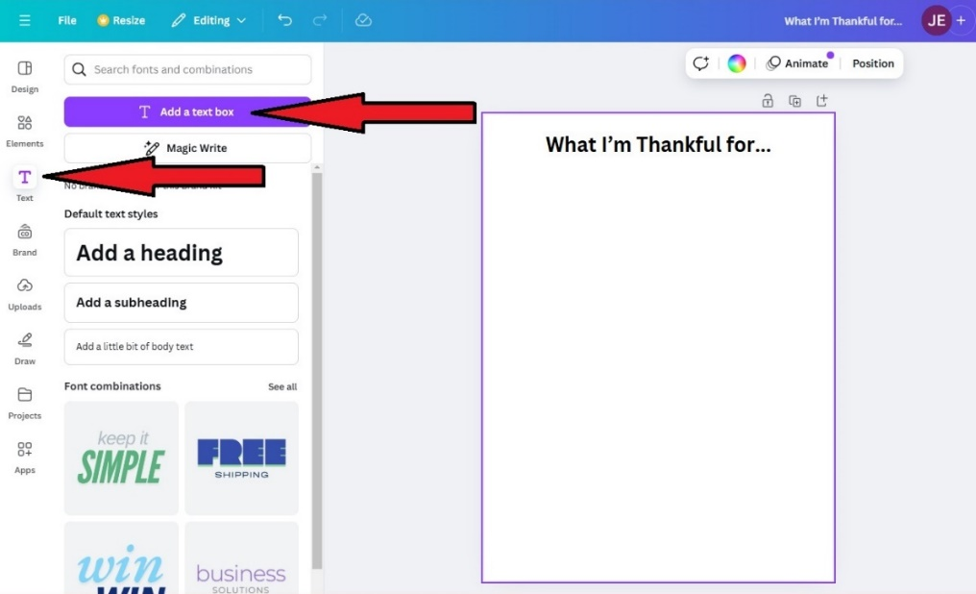

Source: [canva.com](https://www.canva.com/)

After opening a document, you can click on ‘File’ in the upper left corner and edit the title of this project. Afterward, you’ll see a tool bar on the far left. Click the ‘T’, then click “Add a text box”. A text box will appear on the poster. Click in the box to type. You’ll see a tool bar that will permit you to edit the text, like changing the font, size, color, etc. You can also drag the box anywhere in the poster.

1. **Insert elements**

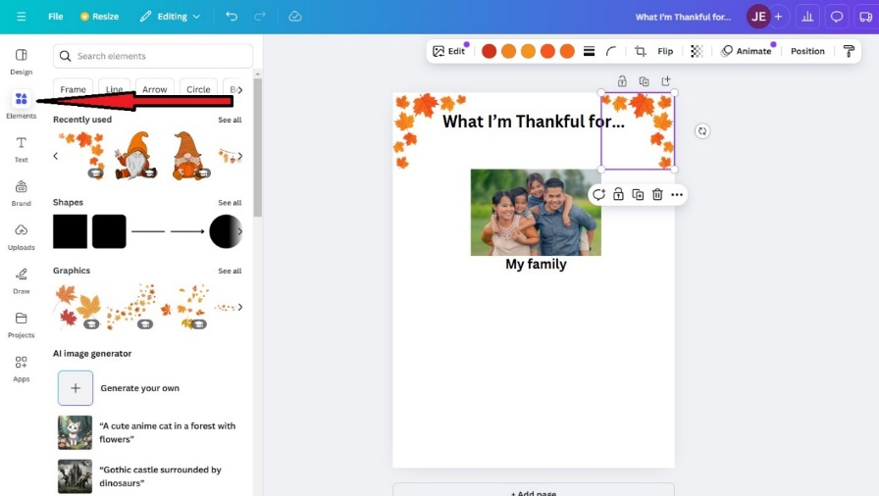

Source: [canva.com](https://www.canva.com/)

Click on ‘Elements’ to open the elements bar. There, you can insert shapes, graphics, photos, stickers, videos, etc. Also, there is an AI image generator that can create pictures. To insert anything, just click it twice. Once inserted, a tool bar will appear at the top of the poster. You can duplicate the image, flip it, change colors, and other things as well. You can also change the size of the elements by dragging on a white circle in the corner. You can drag the elements anywhere in the poster.

1. **Background color**

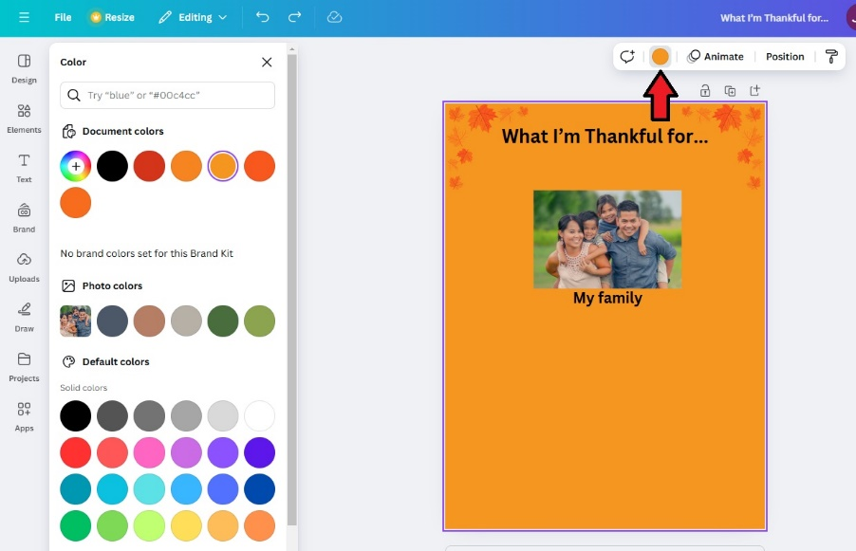

Source: [canva.com](https://www.canva.com/)

To change the background color, click in any blank space on the poster, then click on the color button in the tool bar above the poster. This will open the background color bar on the left where you can select a color.

1. **Markers**

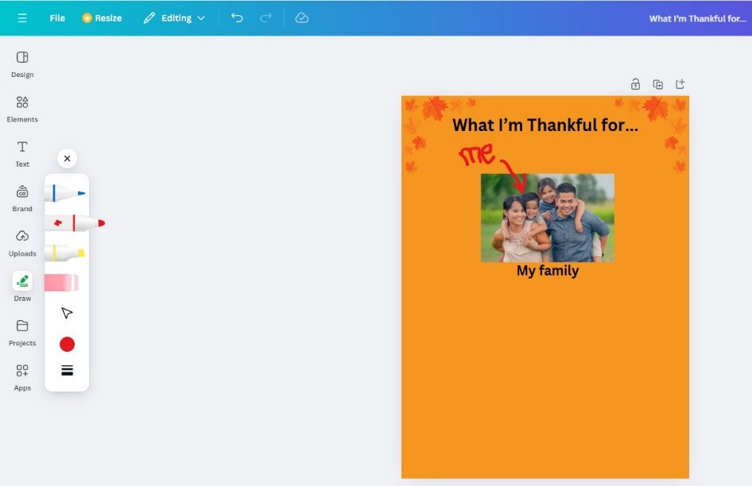

Source: [canva.com](https://www.canva.com/)

The ‘Draw’ tool allows you to choose a writing implement and any color you want to draw directly on the poster. Just choose your implement and drag on the poster.

1. **Uploads**

Source: [canva.com](https://www.canva.com/)

Students can upload images or videos from their devices and insert them into the poster. They can also access files from their cloud storage, like a Google drive. In addition, students can record themselves and embed the audio or video directly onto the poster.

There are other options and tools to explore, like AI tools. You can explore them together with your students or encourage them to explore on their own.

1. **Share the project**

Source: [canva.com](https://www.canva.com/)

There are several ways to share the final product. Click on “Share”, then click “See all” to see all the options.

You can copy a public view link and post it to an LMS page. You can present the poster directly from the Canva page. You can get a QR code to post on social media or send it to a phone. The poster can be embedded onto an LMS page.

Source: [canva.com](https://www.canva.com/)

You can download the poster as a jpeg, png, or pdf. It can be shared to a cloud drive. It can be converted to a Power Point file.

Source: [canva.com](https://www.canva.com/)

The poster can also be shared to social media, via email, or a messenger app.

Source: [canva.com](https://www.canva.com/)