How to use Padlet for the Adjective Activity

Model these steps for your students.
- Click on the plus button
- Choose Image Search 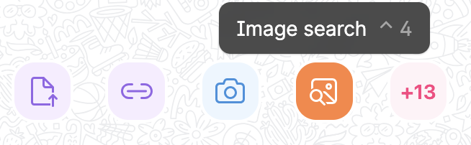

- Show students how to type in a sentence in the box where it says to “search web”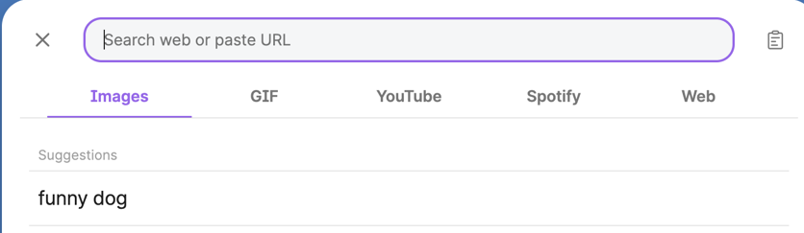

- Choose a picture.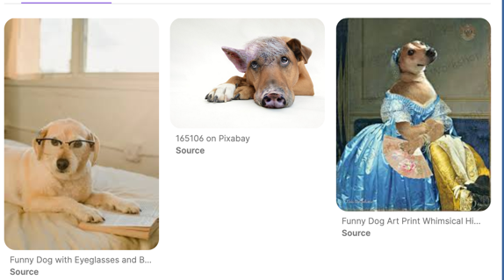

Write their name and a caption. Click Publish.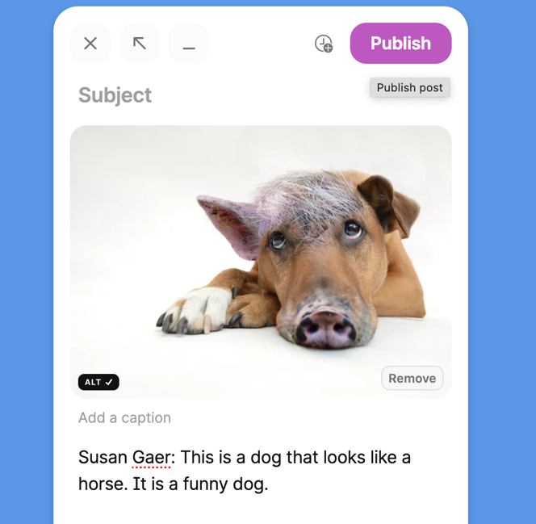

How to Share You Padlet with students.

Click on the share arrow.

Choose whether you want to share the QR code or Share the Link.