AI Media Literacy – Modals of Possibility & Advice
Part 1 – Degree of Certainty
Levels of certainty notes:

Circle the stronger statement in each pair.
- a) This image might be fake.
b) This image must be fake.
- a) The video could be edited.
b) The video must be edited.
- a) People should verify sources.
b) People must verify sources.
A. Modals of Possibility
We use these when something is possible, but not certain.
Modal | Meaning | Example
might | maybe | This image might be AI-generated.
may | maybe | The video may be fake.
could | possibly | The face could be edited.
must | most likely | The hand with six fingers must be made by AI.

Structure:
Subject + modal + base verb
It might be fake.
This could be AI-generated.
The voice may sound unnatural.
The video of the gorilla dancing in a night club must be a hoax.
⚠️ No “to” after most modals
❌ It might to be fake.
✅ It might be fake.

B. Modals of Advice
Use these to give recommendations / advice.
Modal | Meaning | Example
should | good idea | You should check the source.
shouldn’t | not a good idea | People shouldn’t share fake videos.
had better | strongest advice: a very bad idea that has negative consequences | I had better (I’d better) verify this information before posting it on social media.
had better not | strongest advice / warning | You had better not (You’d better not) let AI do your homework because you won’t learn anything.

Structure:
Subject + should + base verb
- You should check the lighting.
- We shouldn’t trust everything online.
- They’d better remove that deepfake video from the website.
- I’d better not share this altered photo of my friend online without her consent.

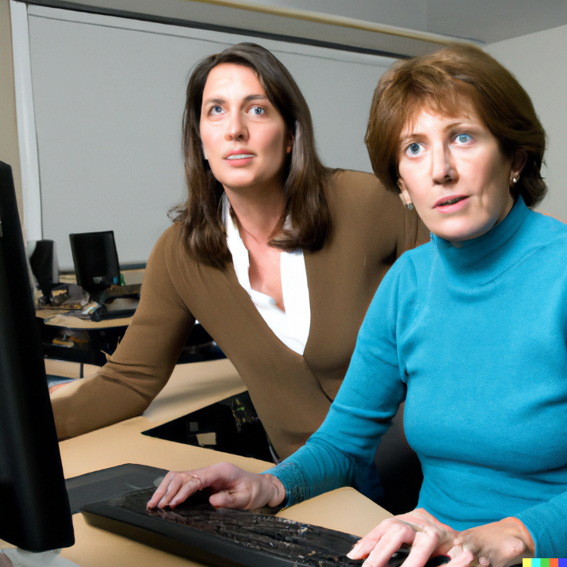
Dall-E generated image
Part 1: Complete the Sentence (more than one answer is OK)
- This image ______ be AI-generated because the eyes look strange.
- People ______ check the website before sharing news.
- The voice ______ be fake because it doesn’t match the mouth.
- We ______ believe everything we see online.
Finish these sentences in different ways:
- This image must be AI-generated because…
- One clue that it might be fake is …. because…
- You should check…

Part 2: Choose Possibility or Advice?
Label each sentence:
- You should look at the background carefully. Possibility Advice
- The video might be edited. Possibility Advice
- People shouldn’t spread false information. Possibility Advice
- This image could be fake. Possibility Advice
Analyze the Clue
Clue: The person in the image has distorted fingers and unnatural skin texture.
Write:
1 possibility sentence:

1 strong certainty sentence:

1 advice sentence:

Critical Thinking Response
Are AI-generated images more helpful or more harmful? Why?
Write sentences using:
- 2 modals of possibility
- 2 modals of advice
- 1 must (strong certainty)

